**User’s guide - E-Farming: An E-Commerce System For Agricultural Products**

The prepose of our application is simple, to enable farmers to directly sell to buyers, without middlemen such as brokers, buyers, and distributors, farmers will be able to earn a larger share of the income.  
by making simple and friendly UI, customers will be able to easily locate the products they desire, while farmers will efficiently manage the goods they offer for sale.  
  
we got four different rules at our application – unregistered user, registered user, farmer, and admin.

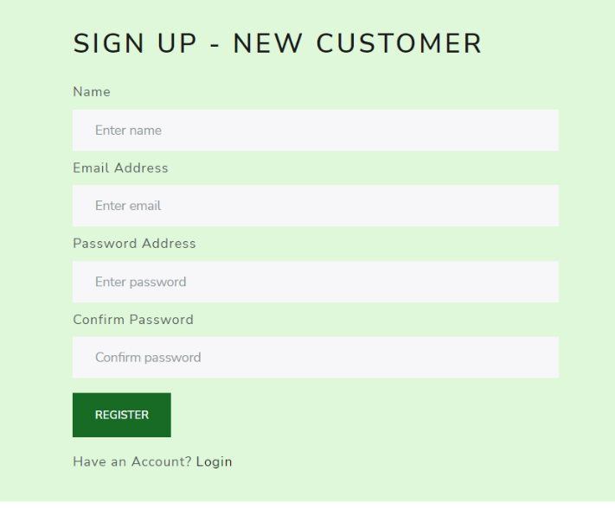The user guide for this project has been divided into several independent sections to reflect the various parts of the system.  
  
**Registration / Login:**To register for the system, users must follow the steps outlined below:  
  
1. Create an account. We got two different types of registration – Customer and Farmer, customer registration requires name, email and password.

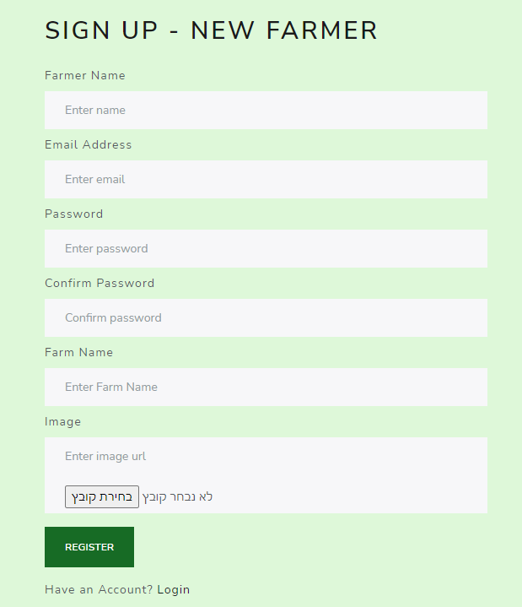Farmer registration requires farmer name, email, password, farm name and image:

Login to our website:

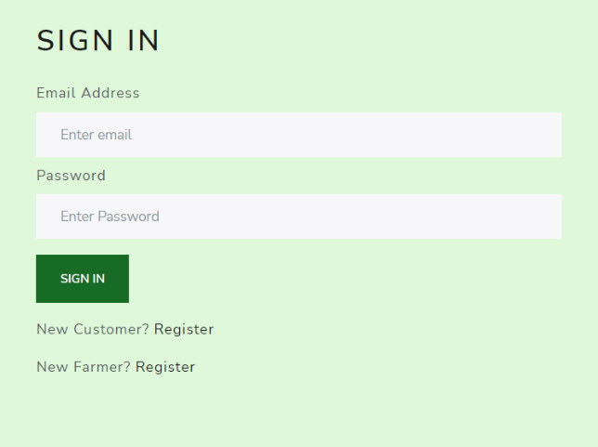

**Customer User - Adding Products To The Cart Process:**

Every user, even those who have not registered, can browse the available products and farmers within the system, in order to reach a specific food product, they have two options: selecting the product first, then the farmer, or selecting the farmer first, then the product.  
They will also have the ability to add food products to their cart and view the items in their cart.  
For the user to successfully operate all that described, he must follow these steps:

In order to reach a specific food product, the user has two options:

1. **Selecting a product first, then the farmer:**
   1. 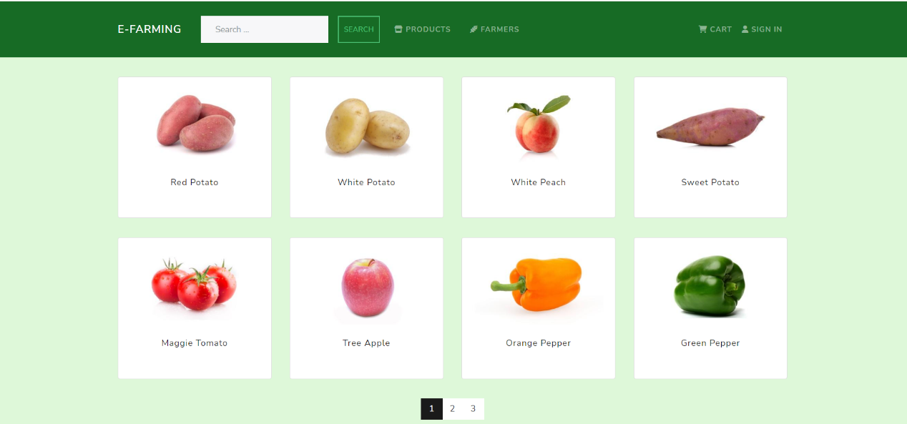At the Home's page, the user needs to select a product from a list of all available products:
   2. After the user selected the desired product, the system displays a list of all farmers who produce it, including their image, name, rating, number of reviews, and the price at which they sell the product.

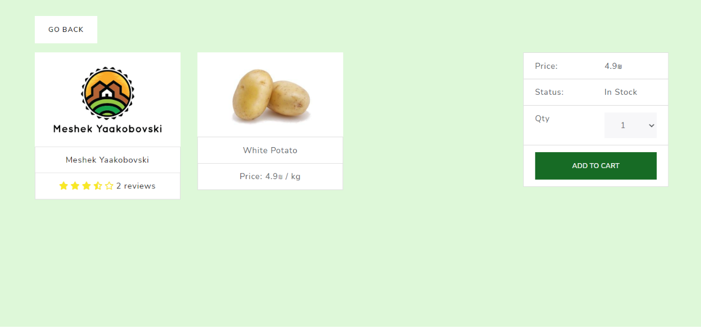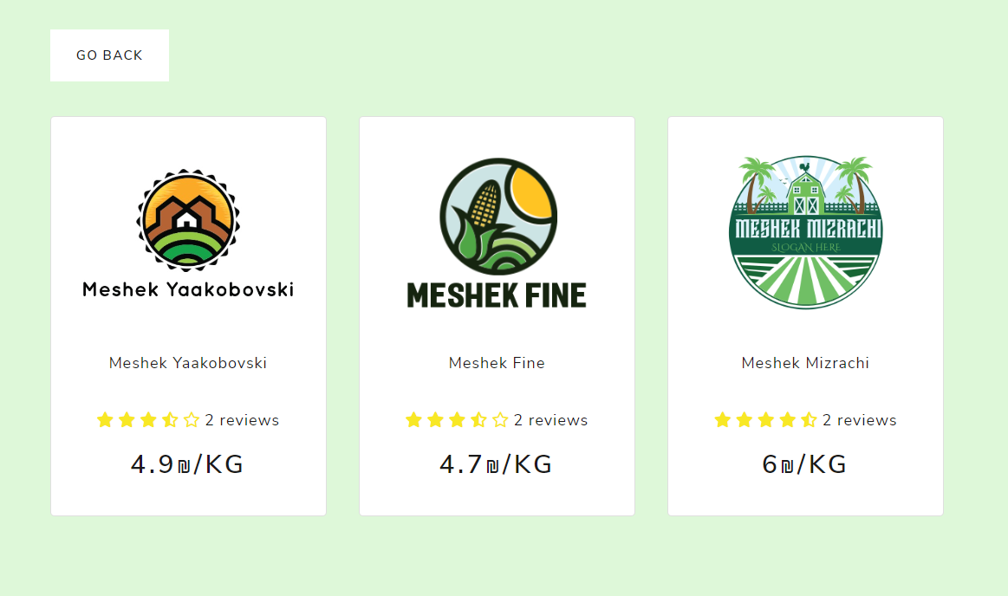  
c. Selecting the farmer's name directs the user to the specific food product page:

1. **Selecting a farmer first, then the product:**
   1. In order to reach the farmers page, the user needs to click on the “Farmers” Button on the navigation header, Upon arriving at the Farmers Page, the system displays a list of all the farmers who have signed up, along with their image, name, rating, and number of reviews.



* 1. 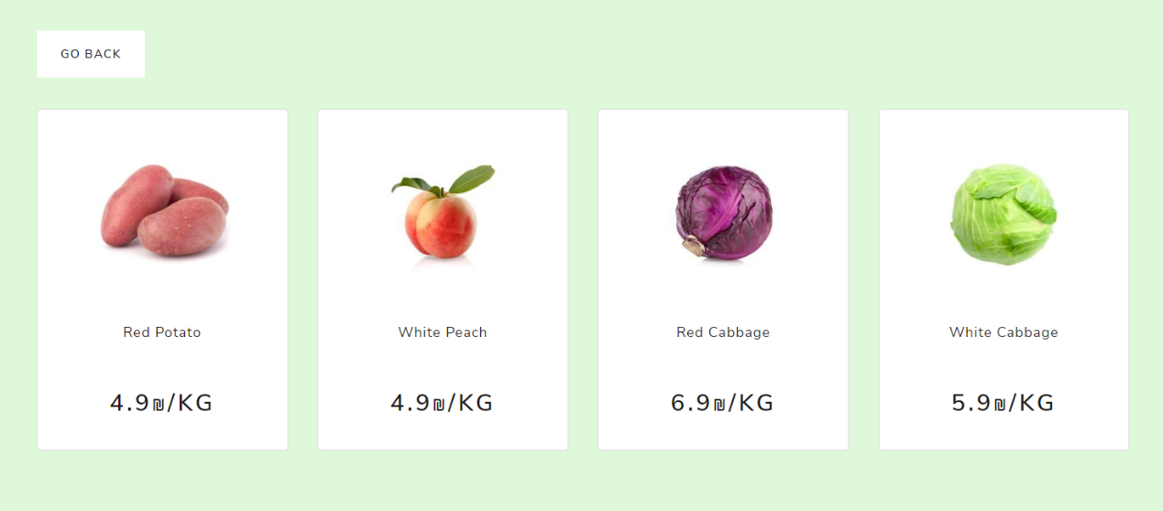Selecting the farmer's name takes the user to a page that displays all of the products produced by the selected farmer:
  2. 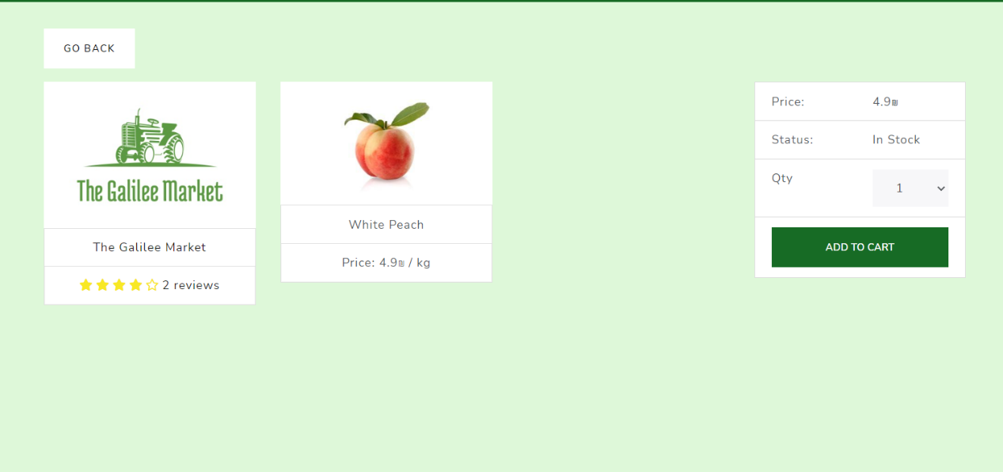Selecting the product's name directs the user to the specific food product page:

Upon arriving on the food product page, the system presents all relevant information about the item, including the producer (the farmer), the product itself, and the price. The user has the option to specify the desired quantity and add the item to their cart.

In order to reach the cart page, the user needs to click on the “Cart” Button on the navigation header:

When the user arrives on the Cart Page, the system displays a summary of all items in the cart, including the total price.  
On the Cart Page, the user has the option to proceed to checkout.

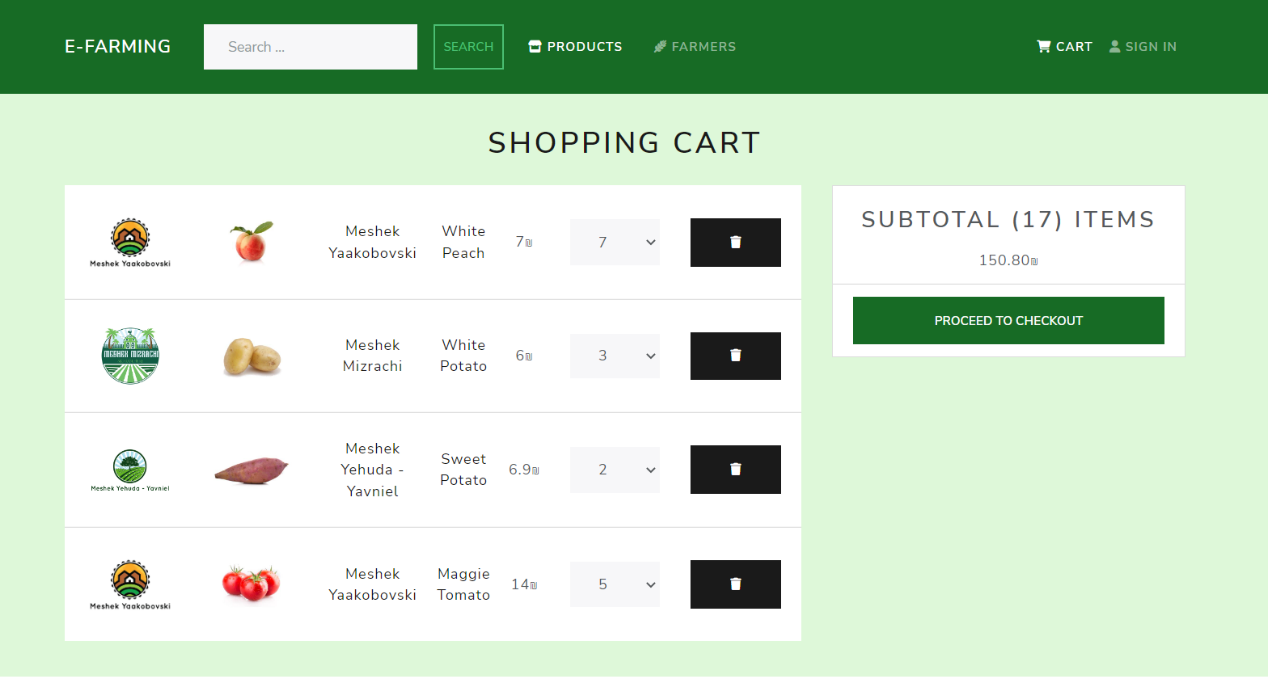

**Customer User - Checkout Process**In order to complete the checkout process (placing orders and payment), the user must follow these steps:  
  
1. In order to start the checkout process, the user needs to Log in to the system.  
2. At the beginning of the checkout process, the user is required to provide their shipping address (including the address, city, and postal code):

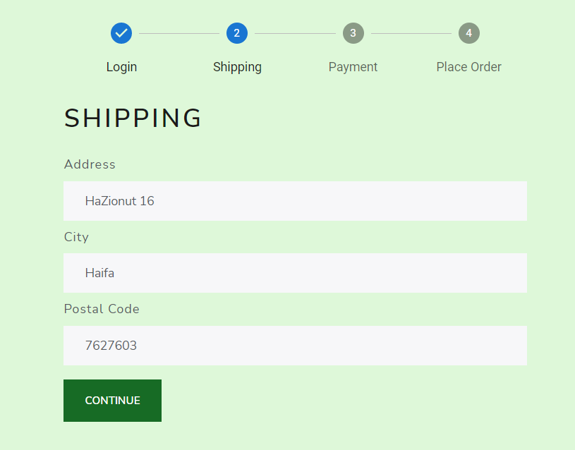

1. After providing the shipping address info, the user is required to provide his preferred payment method:

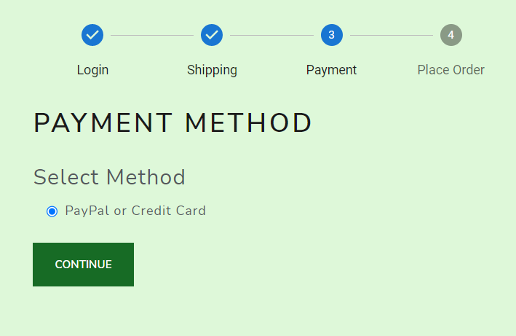

1. 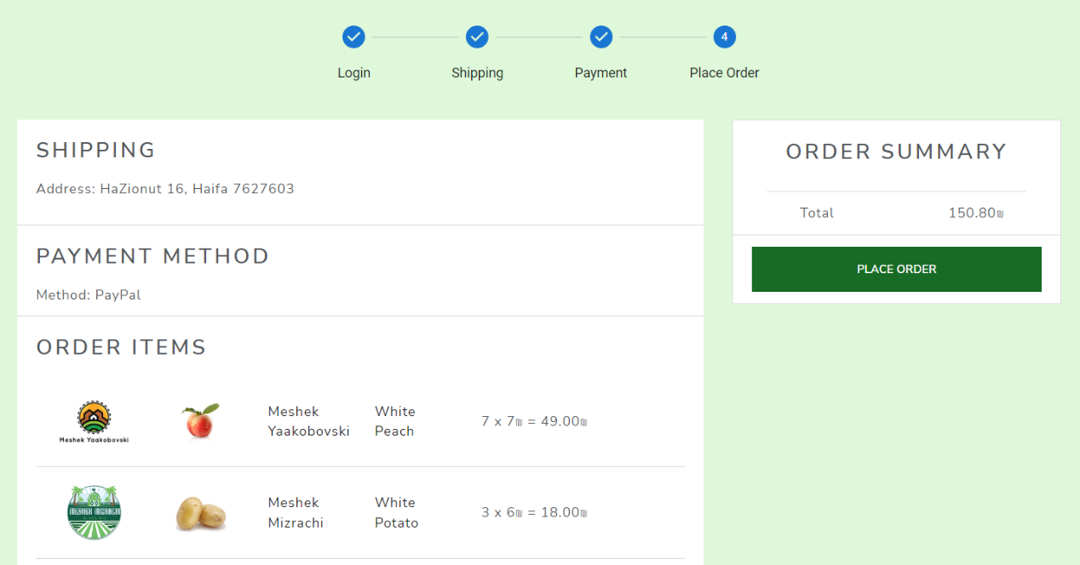After providing the preferred payment method, the user is redirected to the Place Order screen, where they can review all relevant details of the order, including the shipping address, payment method, and a summary of the items in the cart with the total price.  
   Clicking on the “Place Order” button redirect the user to the Payment screen, where he can pay for his order.
2. 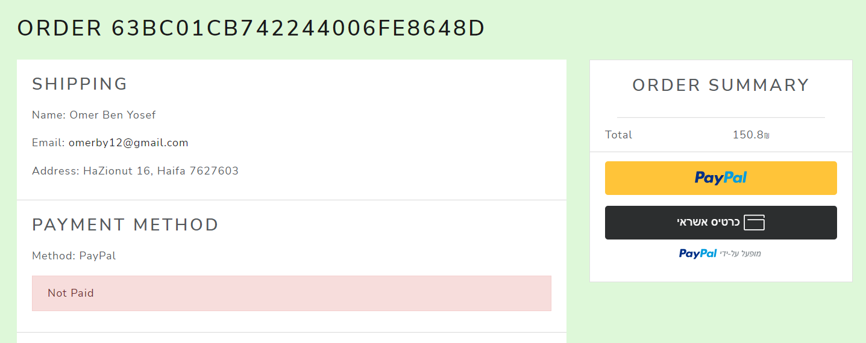On the payment screen, the user needs to pay for this Order (Paying with PayPal).  
     
     
     
   After a successful payment, the payment result is saved on our MongoDB database.

**Customer User - Adding Reviews:**

Upon visiting the farmer's page, the user has the option to view all of the farmer's reviews and submit their own review through a form.  
In order to submit a review for a specific farmer, the user needs to follow these steps:

1. the user needs to click on the “Farmers” Button on the navigation header, upon arriving at the Farmers Page, the system displays a list of all the farmers who have signed up, including their rating and number of reviews.  
In order to watch a specific farmer review, the user needs to click on the reviews text (which direct the user to the farmer page):

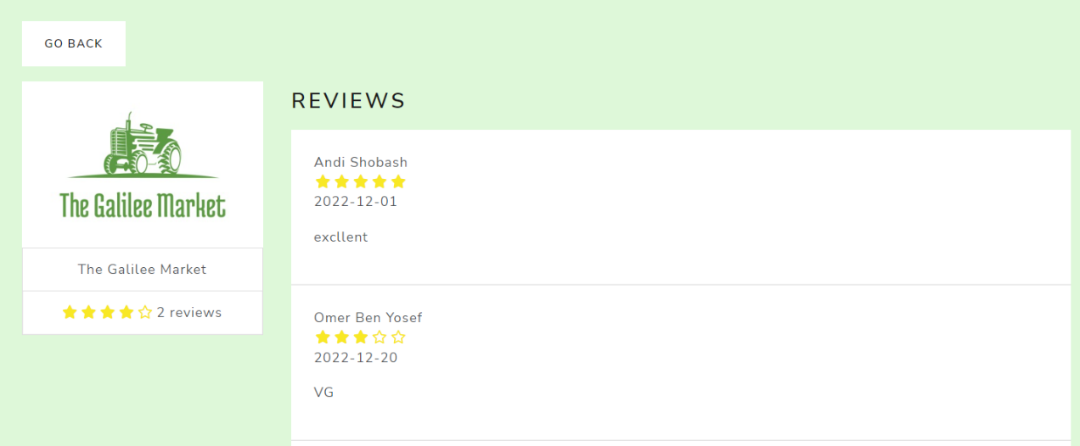2. Upon visiting the farmer's page, the system displays all of the farmer's reviews:

3. If the user wants add a review, he can do so by filling a form. When the form has been submitted, it saved inside our MongoDB database.  
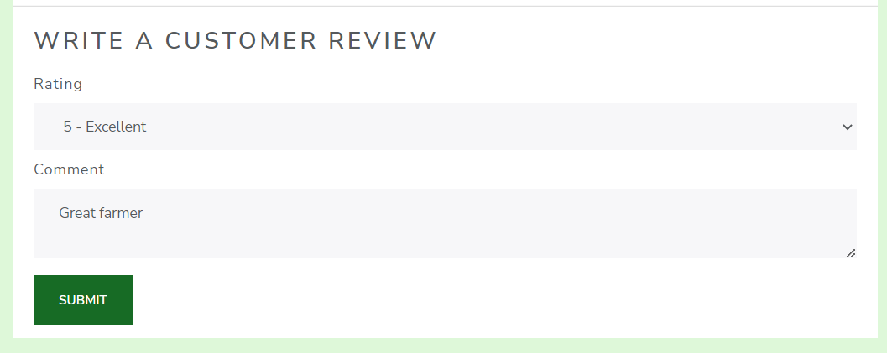  
  
 **Customer User - Orders List**

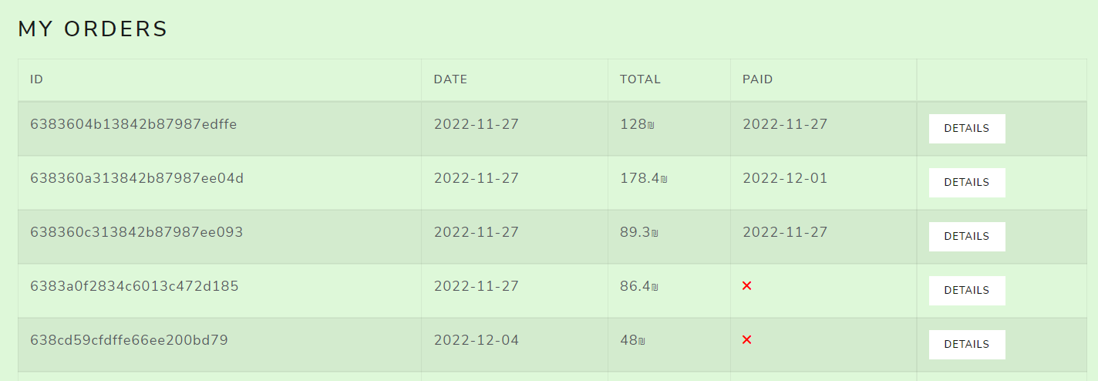A registered user has the option to watch all of his orders, with the corresponding info – id, date, total price.  
  
To watch an order in the system, the user needs to follow these steps:  
  
1. the user needs to click on the “Orders” Button on the navigation header, upon arriving at the Orders Page, the system displays a list of all the user's orders, with the corresponding info – id, date, total price.

2. In case the user wants to see a specific order information, he needs to click on the “Details” Button on the relevant order, by doing so, the system directs the user to the Order Page, where he can see all of the information about the order.  
  
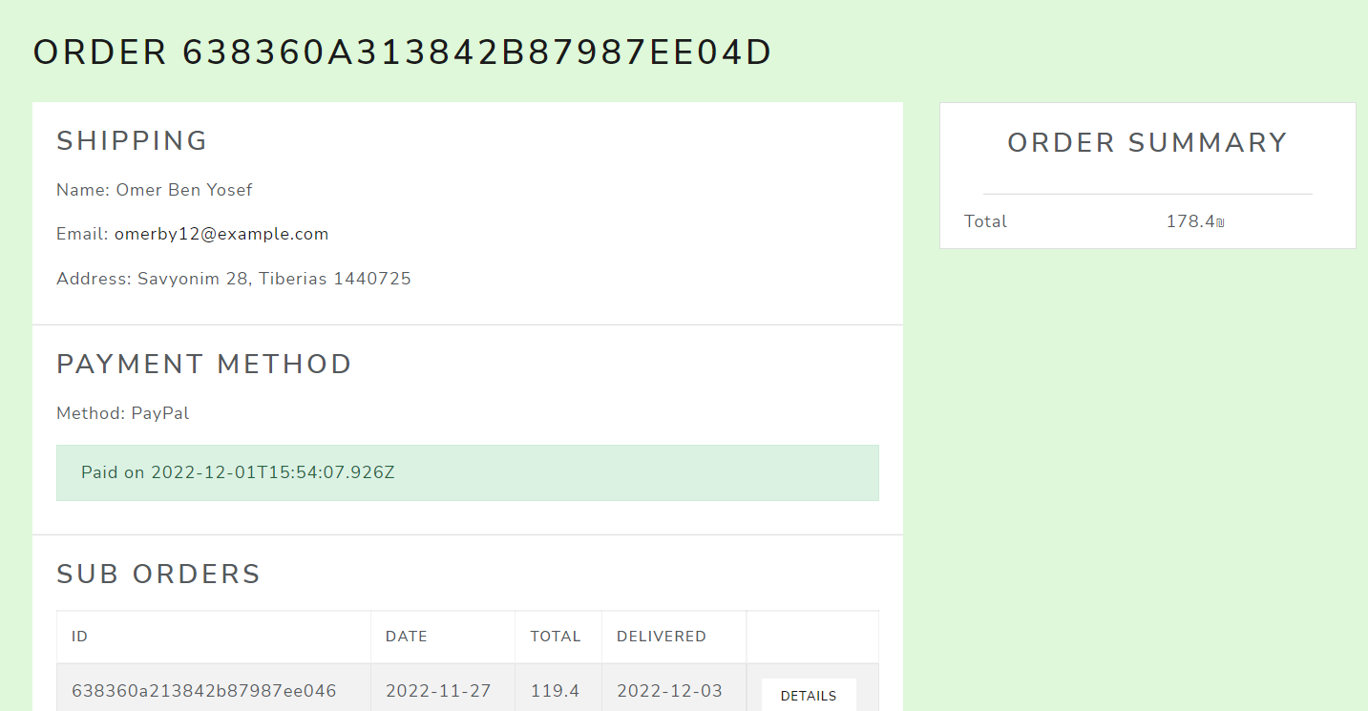

3. Order within the system is composed of a collection of suborders, if the user wants to see a specific suborder information, he needs to click on the “Details” Button on the relevant suborder:

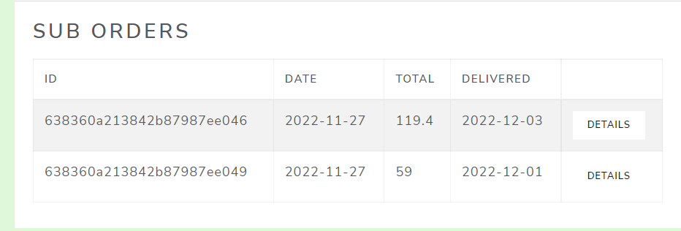

4. Upon arriving at the Sub Order Page, the system displays all the relevant details of the sub order, including the shipping address, summary of the items in the cart with the total price.  
  
  
  
  
  
  
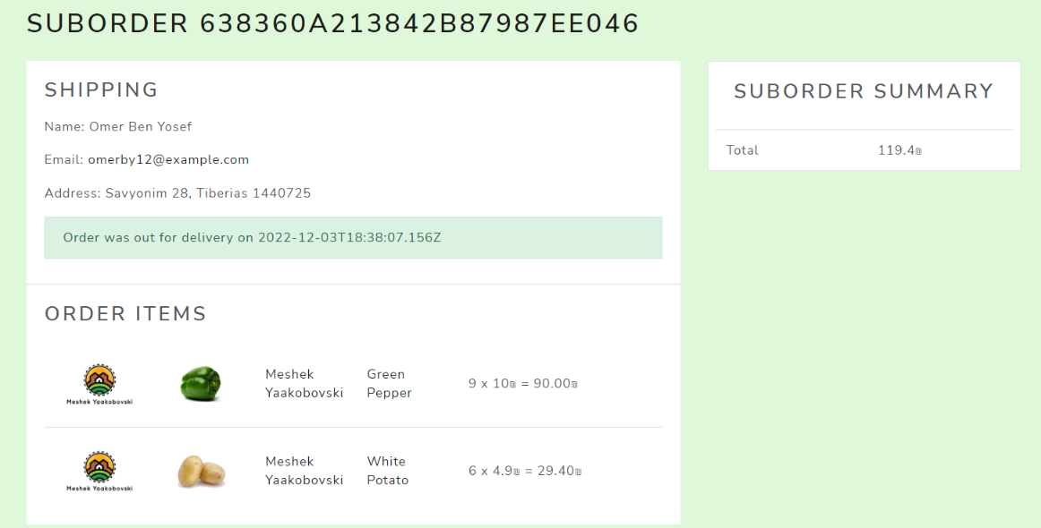

**Farmer User Actions – Managing Products**

Farmers have the option to view a comprehensive list of their food products, including their ID, product type, price, and stock count. In addition, farmers have the ability to easily add new products or modify existing ones, enabling them to effectively manage their inventory and respond to the needs of their customers.

To manage his products, the farmer user needs to follow these steps:

1. 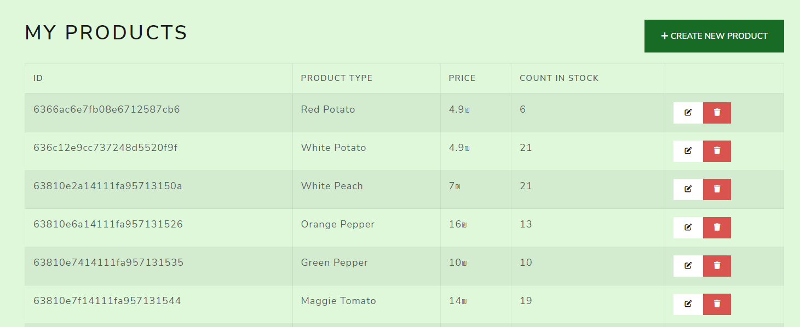After the farmer has logged in, the system displays the list of their food products, the farmer can add a new food product, or editing an existing one:
2. If the farmer wants to add a new food product, he needs to click on “Create New Product” Button, by doing so, the system directs the farmer to a form where he can add a new food product:

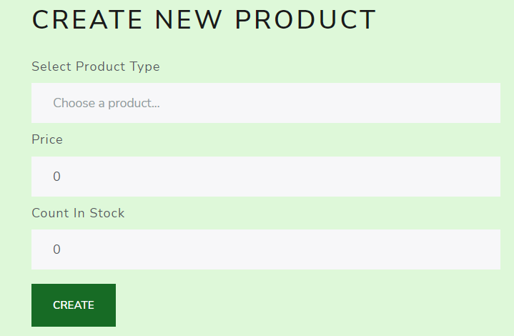

1. If the farmer wants to edit an existing food product, he needs to click on The Edit Button of the relevant food product, by doing so, the system directs the farmer to a form where he can edit the desired food product:

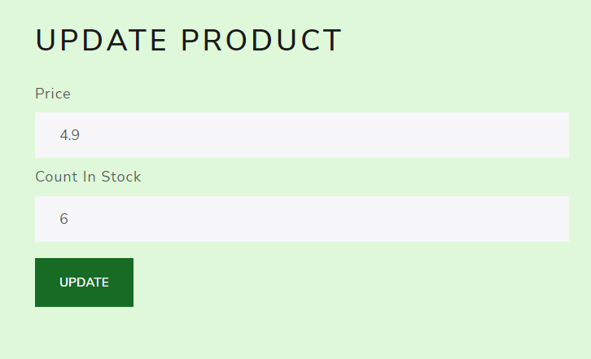

**Farmer User Actions – Managing Orders**

A farmer user has the option to watch all of the orders which are associated with him, If the purchaser has paid for the order, the farmer can mark the order as “Out for delivery”, by doing so – we update the relevant info in our MongoDB database.

To manage the orders which are associated with him, the farmer user needs to follow these steps:  
  
1. the farmer needs to click on the “Orders” Button on the navigation header, upon arriving at the Orders Page, the system displays a list of all the orders which are associated with the farmer, with the corresponding info – id, date, total price.

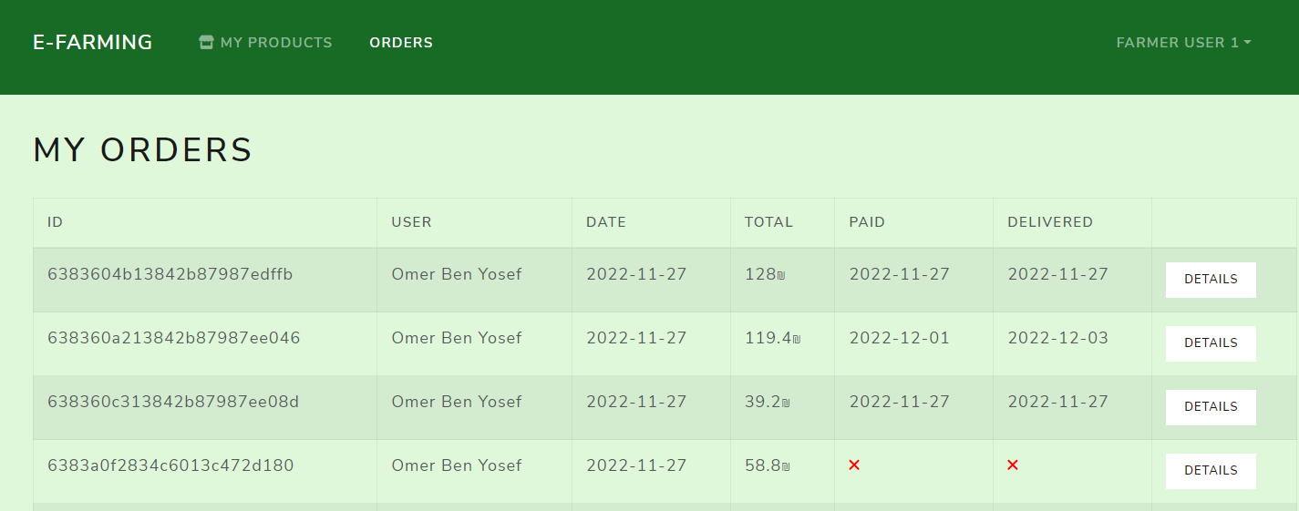

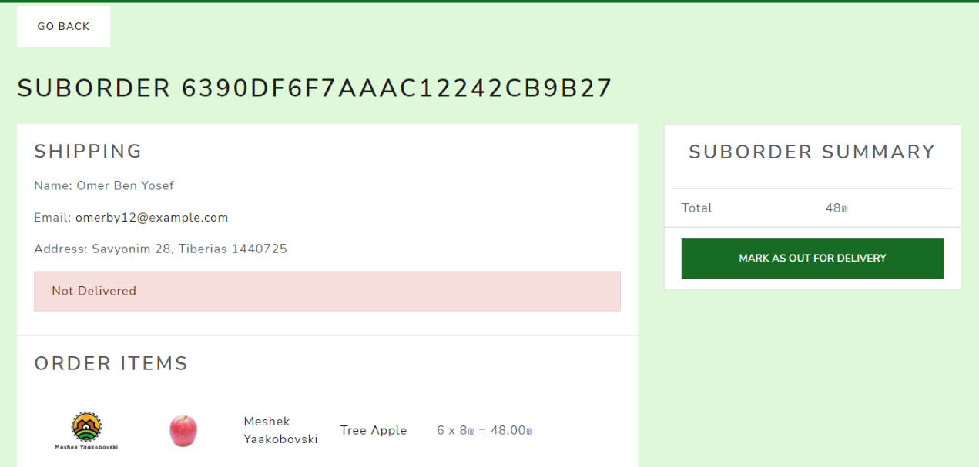2. In case the farmer wants to see a specific order information, he needs to click on the “Details” Button on the relevant order, by doing so, the system directs the farmer to the Order Page, where he can see all of the information about the order, including an option to mark the order as “Out for delivery”:

**Admin User Actions – Managing Products**

An admin user has the capability of adding a new product type to the system, in addition to editing an existing product type.  
  
In order to add a new product type to the system, the admin needs to follow these steps:

1. 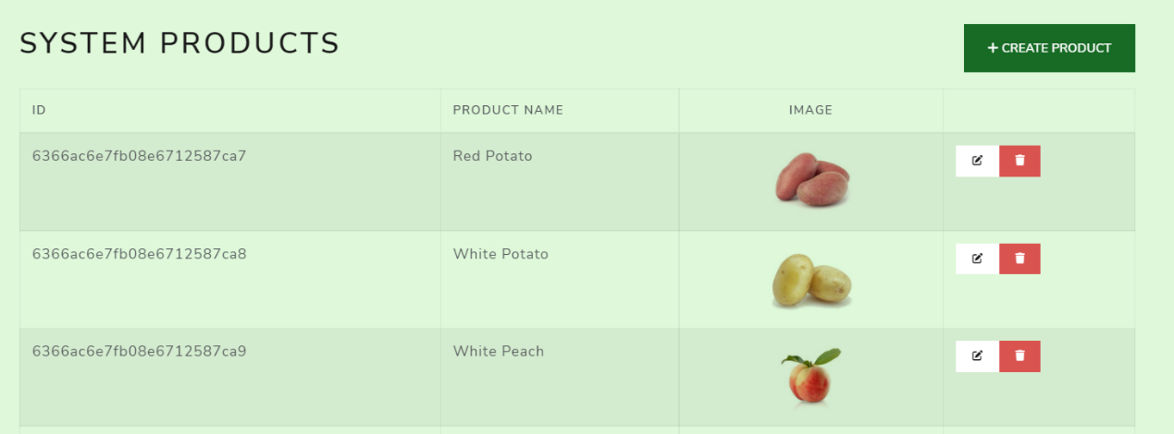After the admin has logged in, the system displays the list of all the products in the system, the admin can add a new product, or editing an existing one:
2. If the admin wants to add a new product, he needs to click on “Create Product” Button, by doing so, the system directs the admin to a form where he can add a new product:

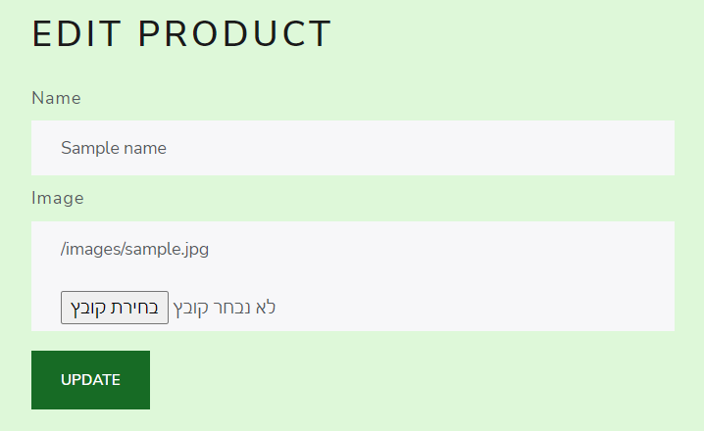The admin needs to fill in the product name and image:

1. If the admin wants to edit an existing product, he needs to click on The Edit Button of the relevant product, by doing so, the system directs the admin to a form where he can edit the desired product:

